Game Design Document

Fill up the following document

1. Write the title of your project.

Robo Fight.

1. What is the goal of the game?

The goal of the game is that the robert will be fighting against the opponent robert. Roberts will be given names according to the players .

1. Write a brief story of your game.

There are two roberts who were once good friends but now as the time has been passing they have parted their ways and they met after many years now they hate each other and want to fight .so here is a gift for them ,rather than fighting in real life they will be fighting virtually without harming each other and they will be awarded with marks as per the moves they use within a certain time and scores will decide who has won that fight and who has lost it.

1. Which are the playing characters of this game?

* Playing characters are the ones who respond to the user based on the input from the user.
* Cars, monkeys, dinos, wizards, etc., are the playing characters in the game.

|  |  |  |
| --- | --- | --- |
| Number | Character Name | What can this character do? |
| 1 | Username will vary | The character can use their legs and hands to beat each other |
| 2 |  |  |
| 3 |  |  |
| 4 |  |  |
| 5 |  |  |
| 6 |  |  |
| 7 |  |  |
| 8 |  |  |

1. Which are the Non-Playing Characters of this game?

* Non-Playing characters are the ones that don't have an action or behavior when the user interacts with the game.
* Hurdles, stones, bananas, coins, etc., are non-playing characters in the game.

|  |  |  |
| --- | --- | --- |
| Number | Character Name | What can this character do? |
| 1 | A boxing ring | Where players will play |
| 2 | A timer | This will show them the time they are left with |
| 3 | Fuel | This will help them charge themselves |
| 4 |  |  |
| 5 |  |  |
| 6 |  |  |
| 7 |  |  |
| 8 |  |  |

Draw your imagination of this game. What does this game look like?

* Draw the game either on your computer or on paper.
* Add images of the game scenes to show each of the playing and non-playing characters at least once.

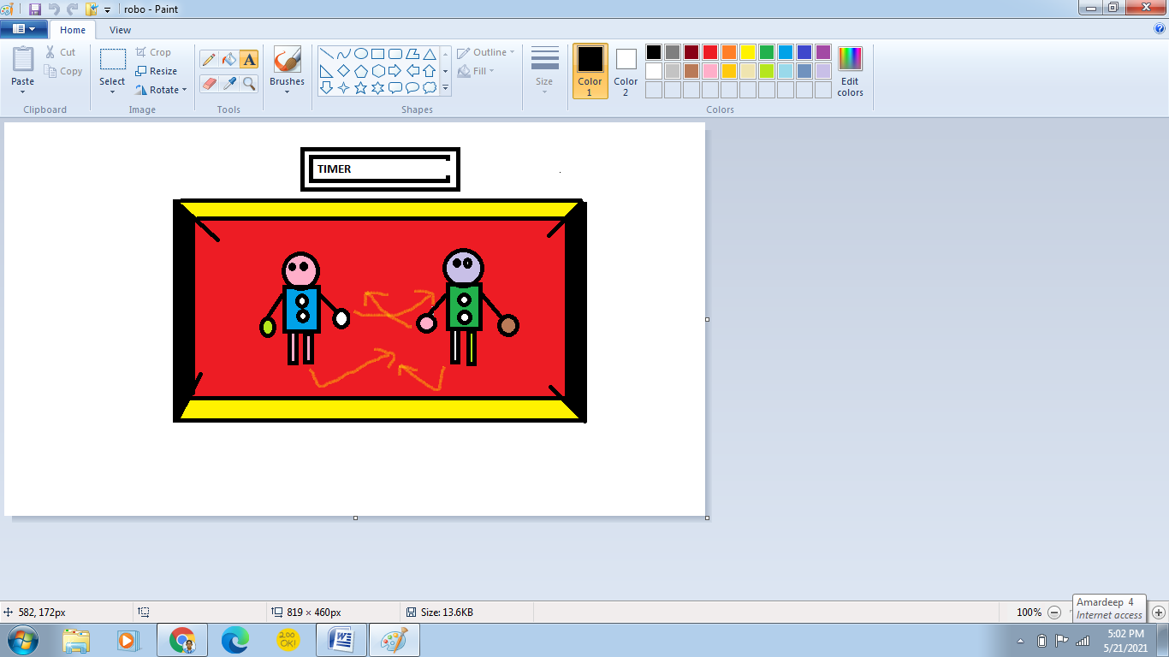

How do you plan to make your game engaging?

By adding attractive sounds on hitting each other .